

**Tribhuvan University**

**A REPORT ON**

**“HANDICRAFT WEBSITE”**

**Submitted to:**

**Department of Computer Science and Information Technology**

**National College of Computer Studies**

*In partial fulfillment of the requirements for the Bachelor degree in Science in Computer Science*

*and Information Technology (B.Sc.CSIT) of Tribhuvan University, Nepal.*

**Submitted by:**

Prakriti Manandhar (26326/077)

Pritika Suwal (26329/077)

Rabina Shakya (26330/077)

**Under the Supervision of**

Sachita Maharjan

May 2024

DISCLAIMER

We hereby declare that this study entitled Handicraft Ecommerce Platform is based on our original research work. Related works on the topic, by other researchers, have been duly acknowledged. We owe all the liabilities relating to accuracy and authenticity of the data or any other information included hereunder.

Signature:

Name of the Student:

Date:

ABSTRACT

This documentation presents an overall overview of the design and implementation of a gadget ecommerce website developed using some of the languages like HTML, JavaScript, MySQL and PHP. This project aims to maintain all the records in a computerized manner to help the supplier to reduce the paperwork. On using this project, customers could view and purchase the product directly. It provides a user-friendly interface that allows staff to perform their tasks with ease, reducing the risk of errors and improving customer satisfaction.

ACKNOWLEDGEMENT

We would like to express our sincere gratitude to **National College of Computer Studies (NCCS)** for providing this platform. In completing this project, we have been fortunate to have help, support and encouragement for many people. We would like to acknowledge them for their cooperation.

Firstly, we extend our heartfelt thanks to our teacher **Mrs. Sachita Maharjan**, for guiding us through each and every step of the process with knowledge and support. Thank you for your advice, guidance and assistance.

This project has been a tremendous learning experience to showcase my ideas, knowledge, vision, etc. We would also like to thank and appreciate each member of the team for their encouragement and support in developing the project.

Lastly, with full dedication, we have created a robust **E-commerce Handicraft Website** that will undoubtedly benefit its use

TABLE OF CONTENTS

DISCLAIMER i

ABSTRACT ii

ACKNOWLEDGEMENT iii

1 Introduction 1

1.1 Purpose 1

1.2 Objectives 1

1.3 Modules 2

1.4 Scope 2

1.5 Limitations 2

2 Background and Literature Review 3

2.1 Background Study 3

2.1.1 Study of existing system 3

2.1.2 Literature Review 3

3 System Analysis and Design 5

3.1 System Analysis 5

3.1.1 Requirement Identification 6

3.1.1.1 Functional Requirements 6

3.1.1.2 Non-functional Requirements 8

3.1.2 Feasibility Study 8

3.1.2.1 Technical Feasibility 8

3.1.2.2 Economic Feasibility 8

3.1.2.3 Operational Feasibility 8

3.1.2.4 Legal and Regulatory Feasibility 8

3.1.3 Data Modeling 9

3.1.4 Process Modeling 10

3.1.5 Class Diagram 13

3.1.6 Sequence Diagram 14

3.1.7 Activity Diagram 15

3.1.8 State Diagram 16

4 Implementation and Testing 17

4.1 Implementation 17

4.1.1 Tools and Technologies 17

4.2 Testing 19

4.2.1 Test Case 19

4.2.2 System Testing 20

5 Conclusion and Future Recommendations 21

5.1 Conclusion 21

5.2 Future Recommendations 21

6 References 22

7 Appendices 23

LIST OF FIGURES

Figure 1: Waterfall Model (SDLC) 6

Figure 2: Use Case Diagram 7

Figure 3: Gantt Chart 9

Figure 4: ER Diagram 9

Figure 5: DFD (Level 0) 10

Figure 6: DFD (Level 1) 11

Figure 7: DFD (Level 2) 12

Figure 8: Class Diagram 13

Figure 9: Sequence Diagram 14

Figure 10: Activity Diagram 15

Figure 11: State Diagram 16

Figure 12: Home Page 23

Figure 13: Footer Page 23

Figure 14: Registration Page 24

Figure 15: Login Page 24

Figure 16: Login Successful Page 25

Figure 17: Category Page 25

Figure 18: Product Page 26

Figure 19: About us Page 26

Figure 20: Contact Us Page 27

Figure 21: Single Product Page 27

Figure 22: Product Successfully Added 28

Figure 23: Cart Page 28

Figure 24: Checkout Page 29

Figure 25: eSewa Integration 30

Figure 26: User Order placed successfully 30

Figure 27: Admin Dashboard 31

Figure 28: Categories page (before adding category) 31

Figure 29: Add categories page 32

Figure 30: Categories page (after adding category) 32

Figure 31: Products page 33

Figure 32: Add product page 33

Figure 33: Admin 34

Figure 34: User 34

Figure 35: Cart 35

Figure 36: Product 35

Figure 37: User Order 36

Figure 38: Contact Us 36

**LIST OF TABLES**

Table 5.2‑1: Test Case Ⅰ 19

Table 5.2‑2: Test Case Ⅱ 20

# Introduction

An e-commerce has revolutionized the way businesses operate, offering immense opportunities for various industries, including handicrafts. Handicrafts represent a significant aspect of cultural heritage and artistic expression in many societies. The integration of e-commerce platforms with handicraft businesses has widened their market reach, enabling artisans to showcase their products globally. This report aims to analyze the key aspects of developing and managing a handicraft e-commerce website.

## Purpose

The main purpose of the handicraft website is to serve as a comprehensive platform for artisans and craftsmen to showcase and sell their handmade products to a global audience. The website aims to provide customers with a seamless shopping experience, allowing them to browse and purchase a wide range of hand-crafted products from the comfort of their homes. It also serves as a dynamic platform that not only facilitates commerce but also promotes cultural exchange, fosters economic empowerment, and preserves the rich heritage of handicraft traditions across the globe.

## Objectives

The objectives of this project are:

* Create user-friendly platform for customers to browse and purchase handicraft products.
* Provide a centralized marketplace to showcase the craftsmanship of artisans.
* Increased developer productivity through usage of easy-to-use tools.
* Improved access to information because of computerizing.
* Implement robust security measures to ensure safe and secure online transactions for both customers and sellers.

## Modules

The site will contain the following features:

• Registration (Sign Up)/Login

• Add to Cart

• Find and buy suitable product

• Feedback module

• Payment option

## Scope

The project's scope extends to the documentation, implementation, and deployment of the Handicraft Website, where the stakeholders can effectively plan and execute the development of this website, ensuring its success in meeting the needs of both artisans and customers.

## Limitations

* Still in development phase.
* Search option not available now.
* Responsive design not available at the moment.
* Shopping cart page.
* Shipping of purchased products on correct location.

# Background and Literature Review

## Background Study

The background section sets the stage by providing an introduction to the handicraft industry and the emergence of e-commerce in this sector. Handicraft is an overview of the significance in cultural heritage, artistic expression, and economic development worldwide. An analysis of recent trends and developments in the global handicraft market which includes the growth projections, consumer preferences, and emerging markets. Also, discussion of challenges faced by artisans, such as limited market access, competition from mass-produced goods, and the impact of globalization, alongside opportunities presented by e-commerce platforms to overcome these challenges. E-commerce platforms provide a convenient and accessible marketplace for artisans to display their unique products, enabling customers to explore and purchase handmade goods. This shift towards online sales presents a promising avenue for artisans to expand their reach, increase sales, and preserve traditional crafts in the digital age.

### Study of existing system

The existing system of a Handicraft website comprises a dynamic online platform designed to facilitate the buying and selling of handcrafted products. It typically features a user-friendly interface where customers can browse through a diverse range of products category, including Wooden frames, Paper masks, glass Stupas, Thanks, Singing bowl. The system includes robust product management capabilities, allowing administrators to add, edit, and update product listings with detailed descriptions, specifications, and images. Additionally, it incorporates secure payment gateways to facilitate seamless and secure transactions, ensuring the protection of sensitive customer information. Furthermore, the system often includes customer account management features, allowing users to create accounts, view details about the products, etc. To enhance the overall user experience, the existing system may also incorporate search and filter functionalities, customer reviews and ratings. Overall, the existing system of a Handicraft website serves as a comprehensive online marketplace, providing customers with access to the products according to their categories.

### Literature Review

Research on the intersection of handicrafts and e-commerce has burgeoned in recent years, reflecting growing interest in the potential of digital platforms to empower artisans and promote cultural heritage preservation. Additionally, research on consumer behavior in the context of online handicraft shopping has shed light on factors influencing purchase decisions, such as perceptions of authenticity, quality, and the emotional appeal of handmade products. Logistics and fulfillment challenges, including international shipping, inventory management, and customer service, have also been the focus of research aimed at optimizing the e-commerce supply chain for handicrafts. Furthermore, legal and regulatory considerations in handicraft e-commerce, such as intellectual property rights, consumer protection laws, and data privacy regulations, have garnered attention from scholars and policymakers alike. Overall, the literature on handicraft e-commerce provides valuable insights into the opportunities and challenges associated with leveraging digital platforms to promote traditional crafts and empower artisan communities in the digital age.

# System Analysis and Design

## System Analysis

Prior to the development of any software system, it is crucial to clearly define the functional and non-functional requirements that will guide its design, implementation, and evaluation. Functional requirements specify the specific functionalities and features that the system must deliver to fulfill user needs, while non-functional requirements outline the quality attributes and constraints that govern the system's performance, security, and usability. In the context of our website development, the following sections delineate the functional and non-functional requirements necessary for creating a robust and user-friendly platform. These requirements serve as a blueprint for developers, ensuring that the website meets user expectations, performs reliably, and adheres to industry standards.

**Methodology:**

The waterfall model was selected as the SDLC model due to the following reasons:

• Requirements were very well documented, clear and fixed.

• Technology was adequately understood.

• Simple and easy to understand to use.

• There were no ambiguous requirements.

• Easy to manage due to rigidity of the model. Each phase has specified deliverables and a review process.

• Clearly defined stages.

• Well understood milestones. Easy to arrange tasks.

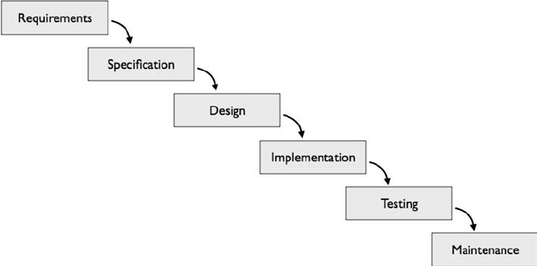

Figure 1: Waterfall Model (SDLC)

### Requirement Identification

Requirements of the system are identified through personal research of visiting various

ecommerce sites.

#### Functional Requirements

* User registration and login
* Product browsing and search functionality
* Shopping cart and checkout process
* Order management for administrators
* User profile management
* Integration with payment gateways
* Product management for administrators (adding, editing, deleting products)
* Customer support features (contact form, live chat)
* Content management system for website administrators

The Use Case Diagram for the Handicraft Website is given below:

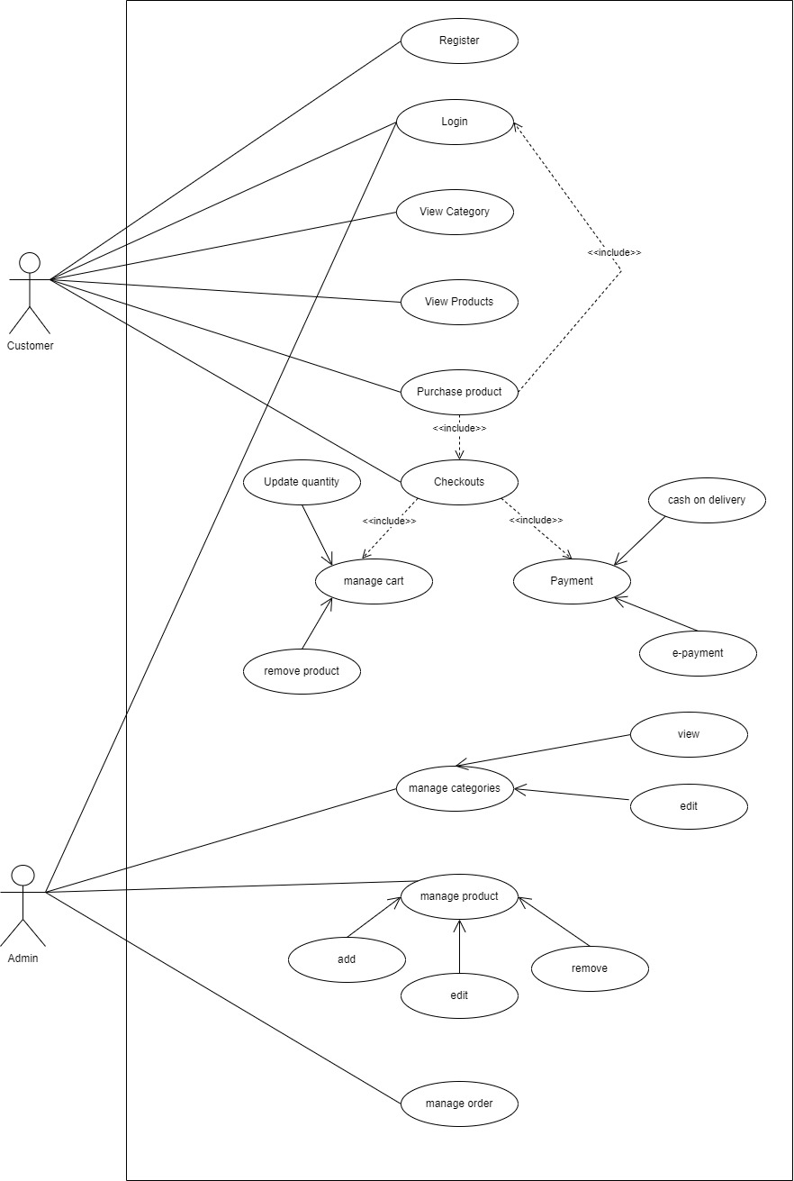

Figure 2: Use Case Diagram

#### Non-functional Requirements

Non-functional requirements for a handicraft e-commerce website may include:

* Performance: Response time, throughput, and scalability to handle concurrent users.
* Usability: Intuitive user interface, accessibility, and responsiveness across devices.
* Security: Data encryption, secure authentication, protection against cyber threats.
* Reliability: System uptime, error handling, and data integrity.
* Compatibility: Compatibility with different browsers, devices, and operating systems.
* Maintainability: Ease of system maintenance, scalability for future enhancements.
* Legal and Regulatory Compliance: Compliance with data protection laws, e-commerce regulations, and industry standards.

### Feasibility Study

Feasibility study assesses the viability of the proposed system from various perspectives, including technical, economic, operational, and legal feasibility. For a handicraft e-commerce website, the feasibility study may involve:

#### Technical Feasibility

Assessing the technical capabilities and resources required to develop the website, including software, hardware, and technical expertise.

#### Economic Feasibility

Evaluating the cost-benefit analysis of developing and maintaining the website, including initial development costs, ongoing operational expenses, and potential return on investment.

#### Operational Feasibility

Analyzing the impact of the website on existing business processes and organizational resources, including staffing, training, and workflow changes.

#### Legal and Regulatory Feasibility

Identifying legal and regulatory requirements that must be addressed to ensure compliance with relevant laws and regulations governing e-commerce operations, data privacy, and intellectual property rights.

|  |  |  |  |  |  |  |  |
| --- | --- | --- | --- | --- | --- | --- | --- |
|  | 1st week | 2nd week | 3rd week | 4th week | 5th week | 6th week | 7th week |
| Planning |  |  |  |  |  |  |  |
| Analysis |  |  |  |  |  |  |  |
| Design |  |  |  |  |  |  |  |
| Coding |  |  |  |  |  |  |  |
| Testing |  |  |  |  |  |  |  |
| Implementation |  |  |  |  |  |  |  |
| Documentation |  |  |  |  |  |  |  |

Figure 3: Gantt Chart

### Data Modeling

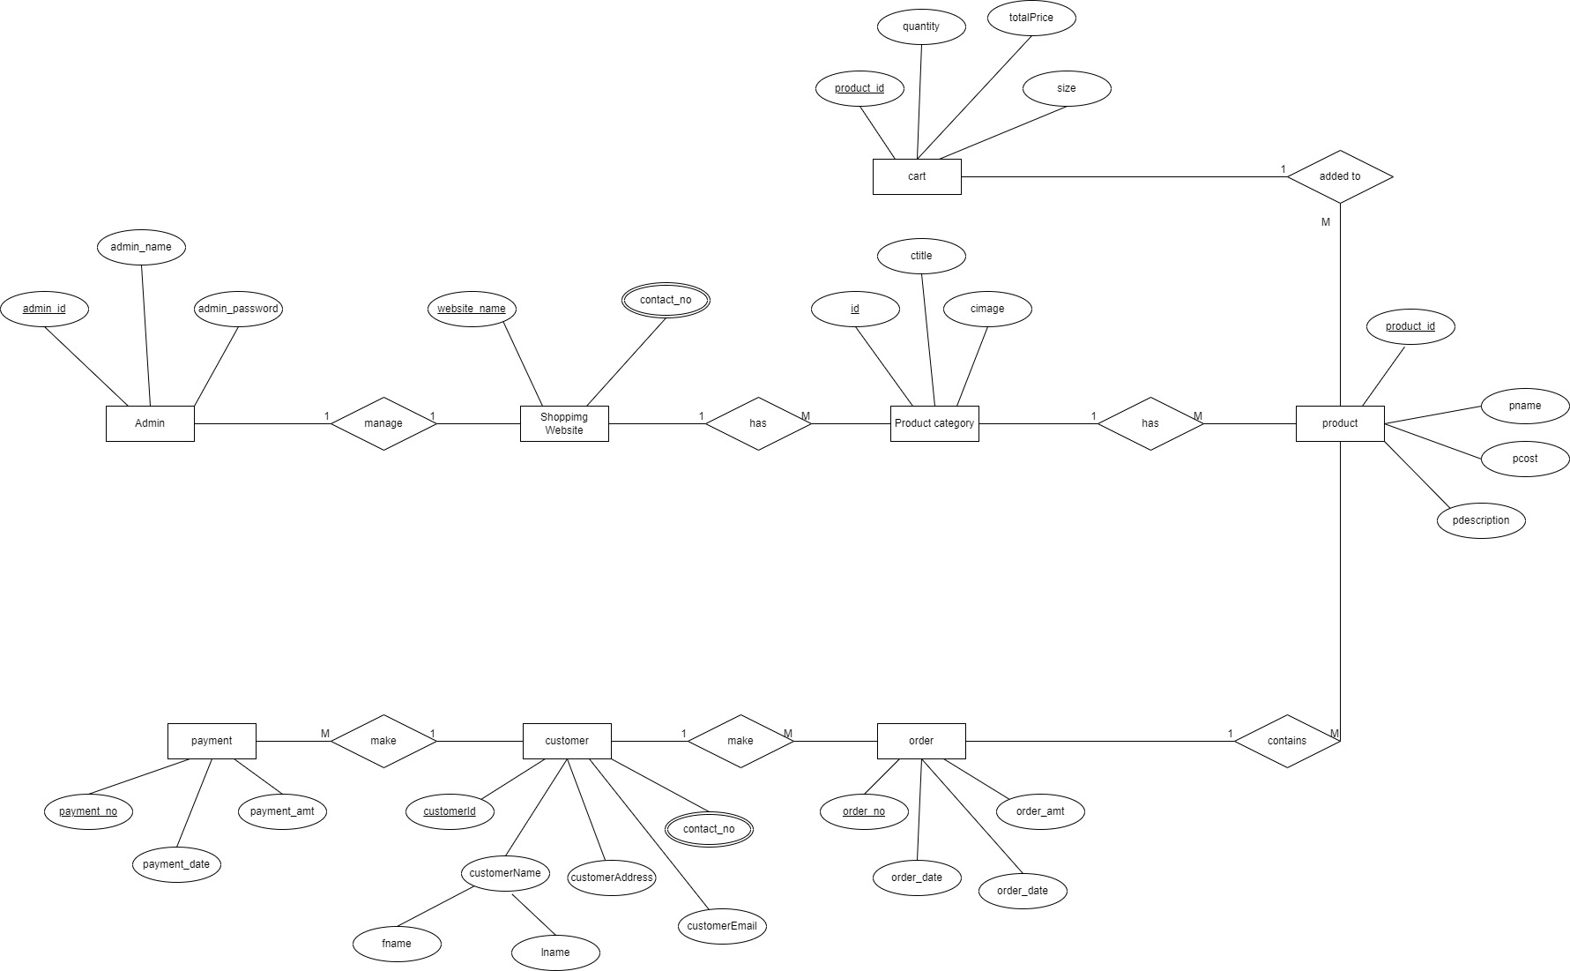

Figure 4: ER Diagram

### Process Modeling

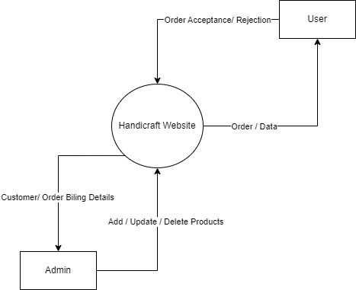

Figure 5: DFD (Level 0)

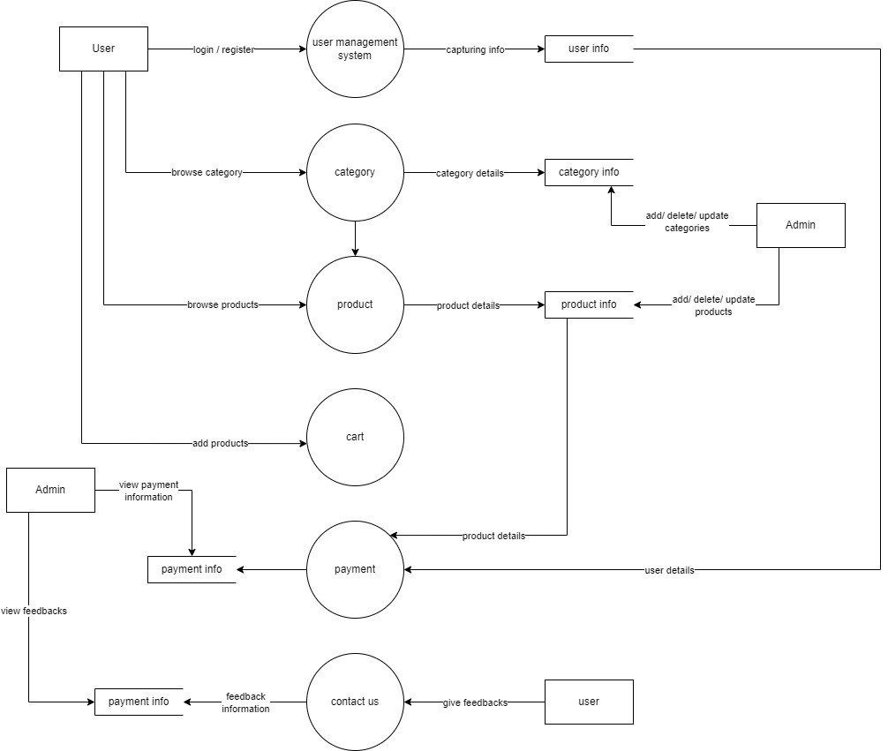

Figure 6: DFD (Level 1)

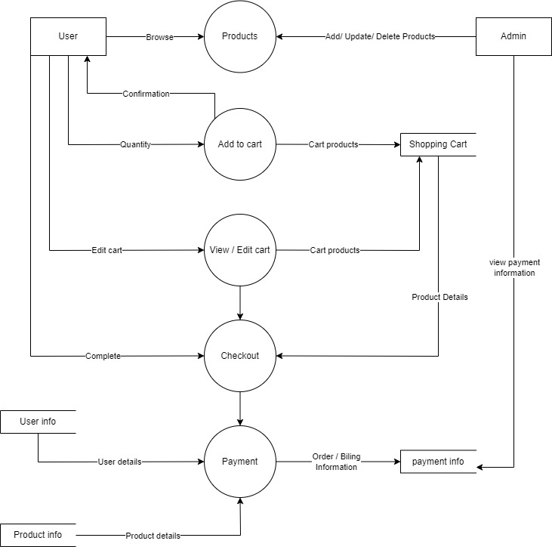

Figure 7: DFD (Level 2)

### Class Diagram

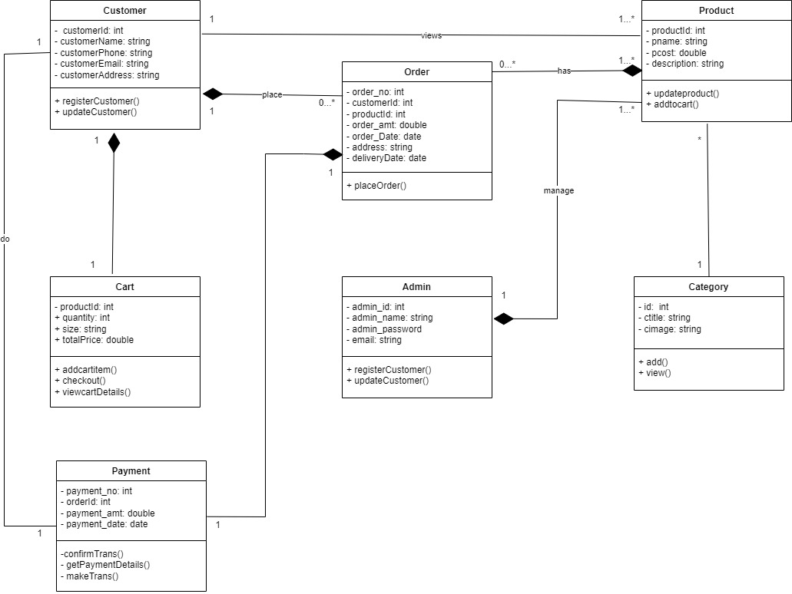

Figure 8: Class Diagram

### Sequence Diagram

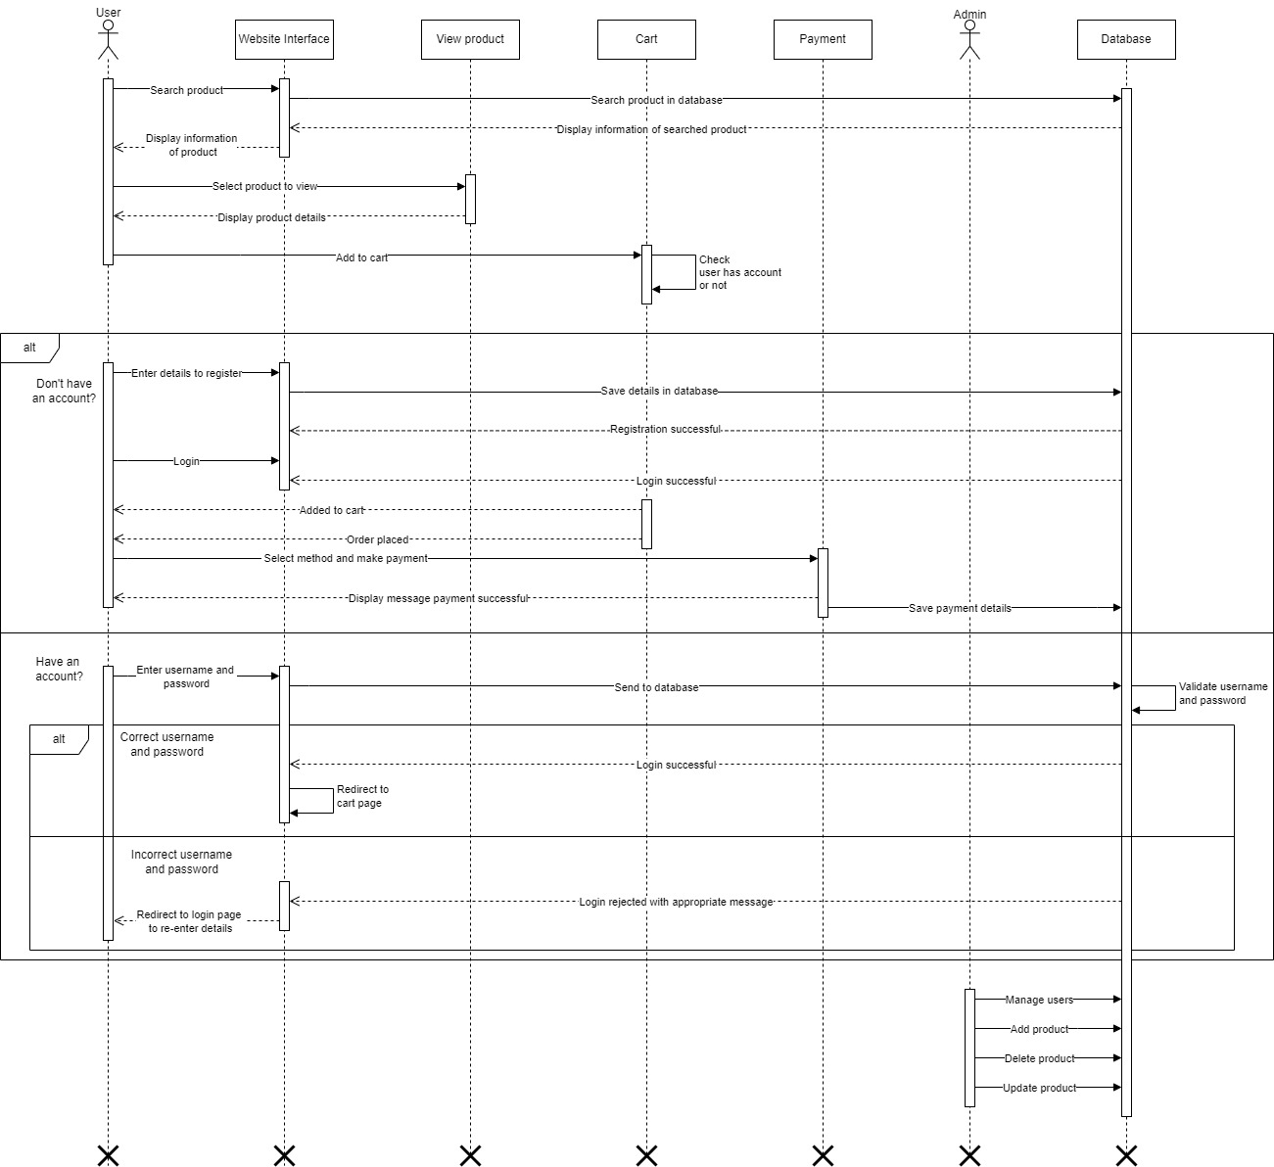

Figure 9: Sequence Diagram

### Activity Diagram

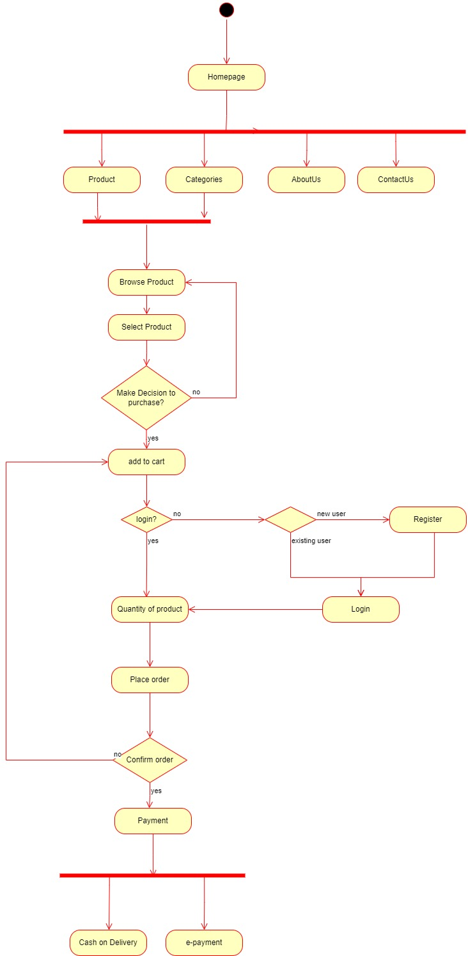

Figure 10: Activity Diagram

### State Diagram

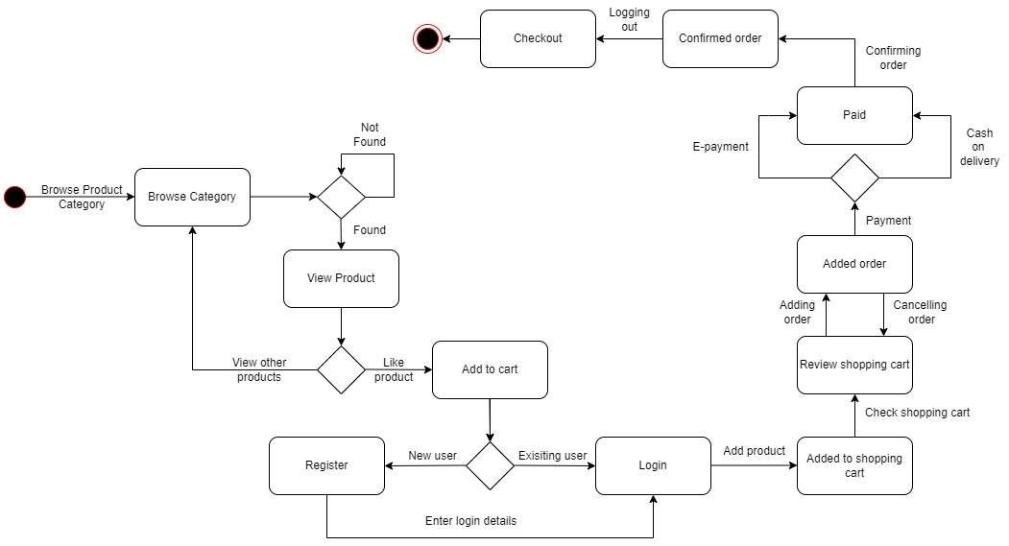

Figure 11: State Diagram

# Implementation and Testing

## Implementation

Implementation denotes the process of converting a new or a revised System design into an operational one.

### Tools and Technologies

The whole system is divided into 2 parts: the front end and the back end.

**Front end Technology:**

Front end development is a technique for creating appealing and marketable website user interfaces. Users want applications that are easy to use and offer modern, reliable functionality. Front end development is vital for visitor retention. The front end attracts people, and the initial page or homepage of the website is the most crucial. While creating a website, the designers should make the navigation simple for users.

* **HTML -** That in which your material is written and in which it is organized. When it comes to website design, HTML plays an important role. Graphics and data tables may be used to arrange content in addition to paragraphs and lists of bulleted points. In the early phases of front-end development, you may utilize many HTML components to surround or wrap certain elements of your content in order to make it seem or act in a specific way. In order to connect a word or image to a different place, enclosed tags are utilized. Tags are the building blocks of HTML.
* **CSS -** CSS is used for the design, animation, and colour-combination of my website until it is ready for development. CSS is free to use on the web HTML is a mark-up language that allows us to include multimedia elements like images and videos, as well as formatting elements like headers and paragraphs. CSS is used to create the page layouts, colours, and fonts of the website. CSS is responsible for the aesthetic appeal of your website's pages.
* **JS -** Use of JS is required for dynamic web sites. Because it's the usual option for web development, I utilized JS while building this website. If anything on the screen moves, we don't need to reload a page every time. I used JavaScript, a scripting language, to add interaction and automation to my website since I didn't want it to be just a collection of static pages. Using this platform, I was able to construct and design a visually beautiful and fast website with a broad variety of customizations to produce a suitable user experience.

**Back End Technology:**

Backend is a technical term that is used by computer professionals and coders. Basically, the backend is the programmer’s code that deals with server-side operations, including CRUD functions with database and all server logic.

The majority of operating syntax and data is backlogged and obtained in the backend of any application. Users can’t access the backend of any computer application.

* **PHP -** PHP code is usually processed on a web server by a PHP interpreter implemented as a module or as a CGI executable. On a web server, the result of the interpreted and executed PHP code – which may be any type of data, such as generated HTML or binary image data – would form the whole or part of an HTTP response. The back end of gadget ecommerce website is done by using the PHP. Implementing a PHP backend for an ecommerce website involves building the server-side logic and database functionality to handle various aspects of the online store, such as user authentication, product management, shopping cart functionality, order processing, and more.
* **Database -** A database is a structured collection of data organized and stored electronically in a computer system. It serves as a central repository for storing, managing, and retrieving data efficiently. In the context of an ecommerce website, a database plays a crucial role in storing various types of information related to products, customers, orders, and more. For example, the product database contains details about each item available for sale, including product names, descriptions, prices, and inventory quantities. Similarly, the customer database stores information about registered users, such as their names, email addresses, and purchase history. The order database tracks details about each transaction, including items purchased, payment information, and shipping details. By organizing data into structured tables and using relational databases, ecommerce websites can effectively manage large volumes of information and provide users with seamless shopping experiences.

**Other Platforms used:**

**Draw.io:** For this project, diagrams including the Use Case diagram, E-R diagram are made using the website Draw.io.

## Testing

The procedure of system testing has the objective of finding every flaw in our project. The project was given a series of test inputs, and numerous observations were made. It will be determined whether the program behaves as expected or not based on these observations.

### Test Case

Table 5.2‑1: Test Case Ⅰ

|  |  |  |  |
| --- | --- | --- | --- |
| Description | Expected result | Actual result | Status |
| User Registration | User is successfully registered | User is registered and stored in database | Pass |
| User Login | User is able to login successfully | User is logged in with correct credentials | Pass |
| View Products | Description of all the products | As expected | Pass |
| Buy Products | Add products to cart and buy the products through various online payment platforms | Store the details of the selected product and transaction process in the database | Pass |
| Feedback | User is able to contact the admin | Feedback of the user is stored in the database | Pass |

### System Testing

Table 5.2‑2: Test Case Ⅱ

|  |  |  |  |  |  |
| --- | --- | --- | --- | --- | --- |
| Test Case ID | Description | Input | Expected result | Actual result | Status |
| ST-1 | Open the browser and enter the URL | http://localhost/user/index.php | Login page must be displayed | As expected | Pass |
| ST-2 | Enter login id | | | | |
| Valid | Username: “testing”  Password: “test” | Accept and display home page | As expected | Pass |
| Invalid | Username: “test”  Password: “demo” | Show invalid credentials message | As expected | Pass |
| ST-3 | Click a product for browsing | Click | Products within selected category are displayed | As expected | Pass |
| ST-4 | Click “Add to cart” | Enter valid quantity of product | Should store the details in the cart | As expected | Pass |
| ST-5 | Click cart icon in the navigation bar | Click | Should show all the details regarding the product | As expected | Pass |
| ST-6 | Choose payment method | Click | Show success message and store the delivery and product details in the database | As expected | Pass |
| ST-7 | Admin Dashboard | Admin logs in and accesses dashboard | Admin dashboard displays relevant metrics and controls | As expected | Pass |

# Conclusion and Future Recommendations

## Conclusion

In conclusion, the **Handicraft Website** project represents a significant milestone in promoting artisanal craftsmanship, fostering cultural exchange, and driving economic empowerment. The development and implementation of this website project has played a role at bridging the gap between artisans and global consumers, promoting cultural heritage, and fostering economic empowerment. With the help of planning, analysis, design, and testing, the project has successfully come to an end with the creation of a robust online platform that showcases the craftsmanship of artisans from diverse backgrounds and enables seamless transactions for users worldwide. The project has laid a solid foundation for future growth and impact in the dynamic landscape of e-commerce and cultural preservation.

## Future Recommendations

* **Enhanced User Experience:** Continuously improving the website's user interface, navigation, and overall user experience to ensure seamless browsing, easy product discovery, and intuitive checkout processes.
* **Advanced Search Functionality:** Enhancing the website's search capabilities with advanced filtering options, predictive search suggestions to help users find products more efficiently and accurately.
* **Interactive Features:** Incorporating interactive elements such as 360-degree product views and product customization tools.
* **Mobile Optimization:** Prioritizing mobile responsiveness and optimizing the website for various devices and screen sizes to cater to the increasing number of users accessing the internet via smartphones and tablets.

# References

*Academia*. (2024). Retrieved from https://www.academia.edu/

*creately*. (2008). Retrieved from https://creately.com/diagram/example/hjom4wgu2/e-commerce-erd

*freeprojectz*. (n.d.). Retrieved from https://www.freeprojectz.com/

*Meera Academy*. (2020). Retrieved from https://meeraacademy.com/use-case-diagram-for-online-shopping/

*scribd*. (2024). Retrieved from https://www.scribd.com/docs

*Slide Share*. (2006). Retrieved 07 15, 2021, from https://www.slideshare.net/sanjeevjain73550/comuputer-processor

# Appendices

**User Page:**

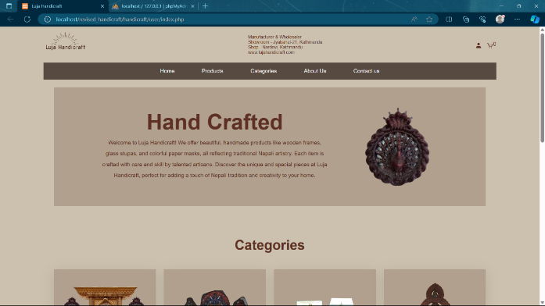

Figure 12: Home Page

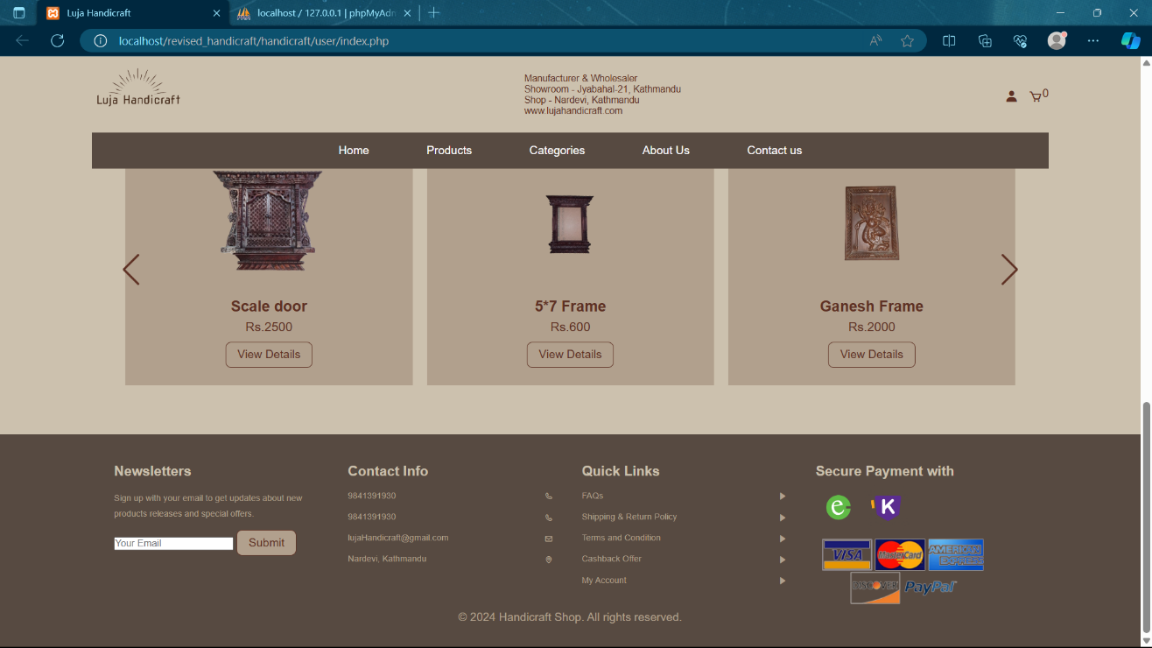

Figure 13: Footer Page

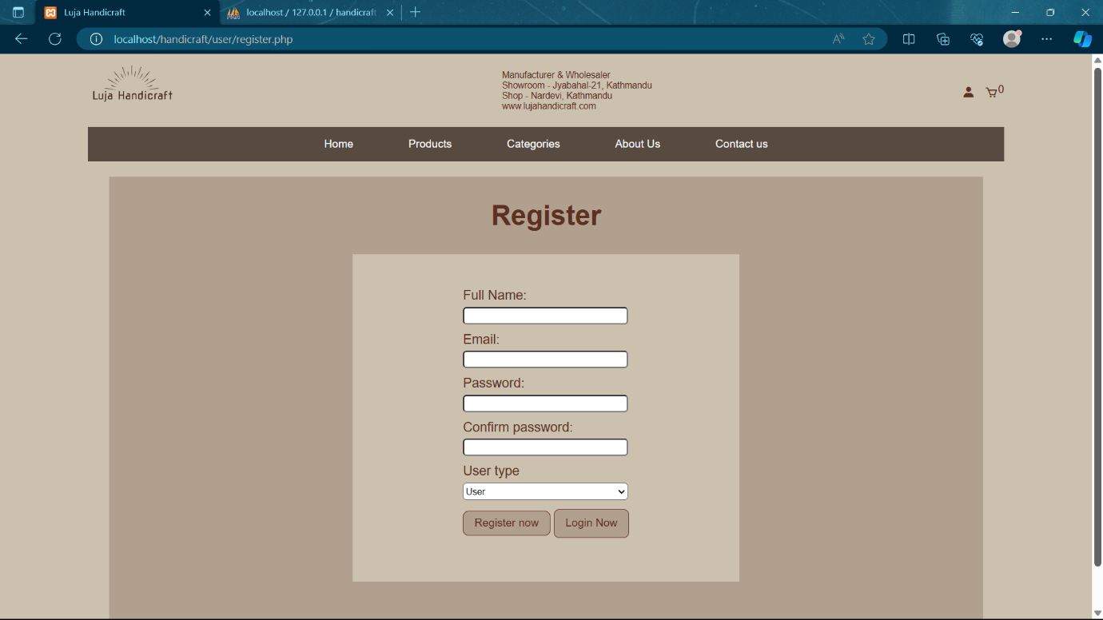

Figure 14: Registration Page

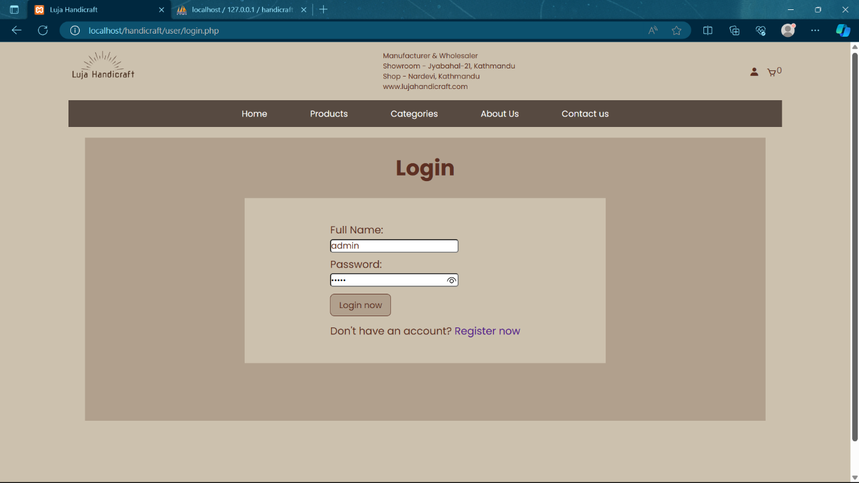

Figure 15: Login Page

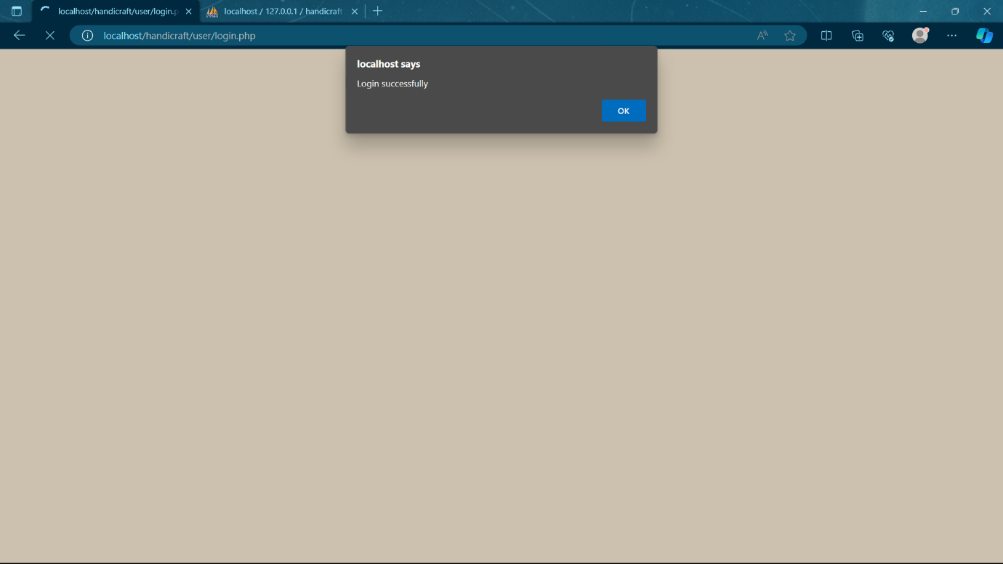

Figure 16: Login Successful Page

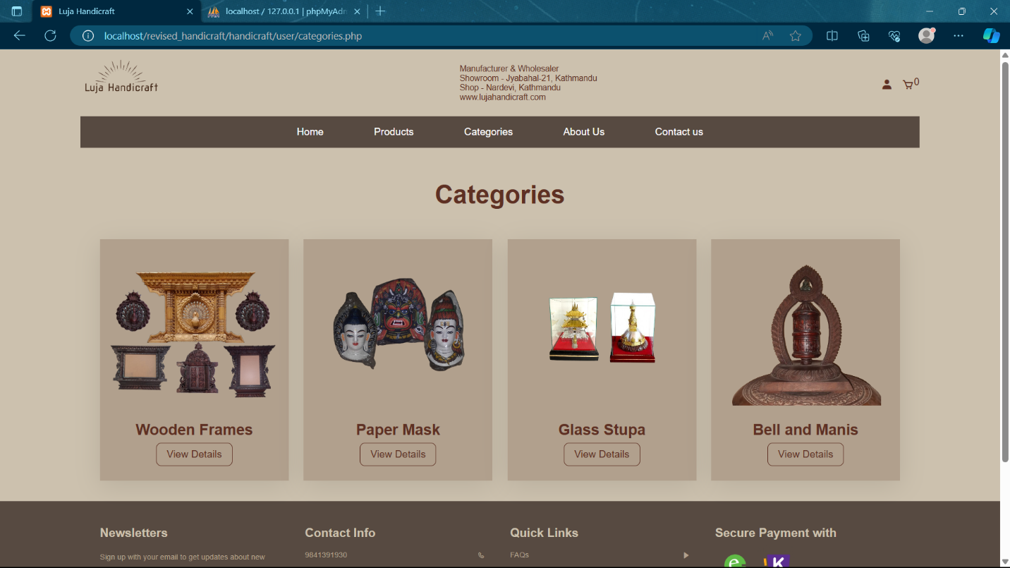

Figure 17: Category Page

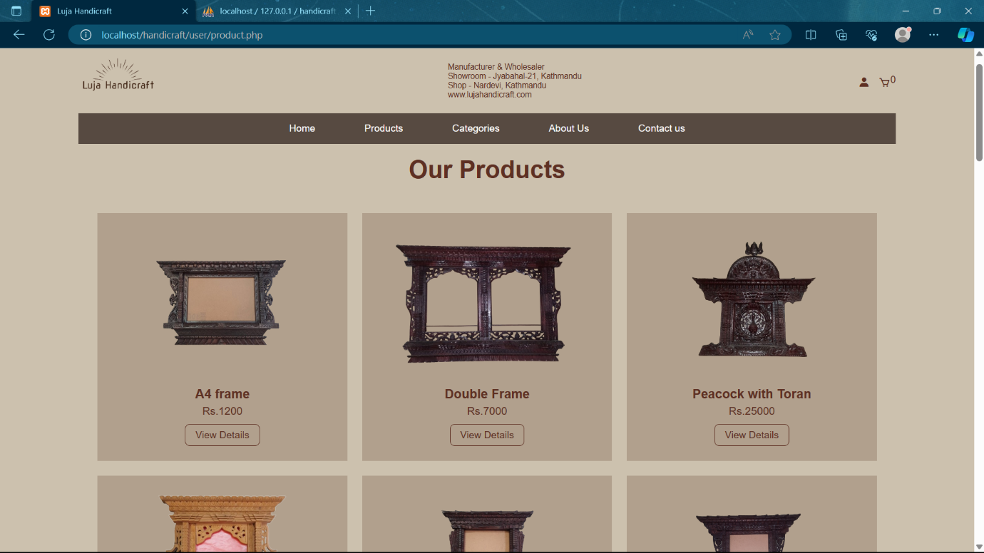

Figure 18: Product Page

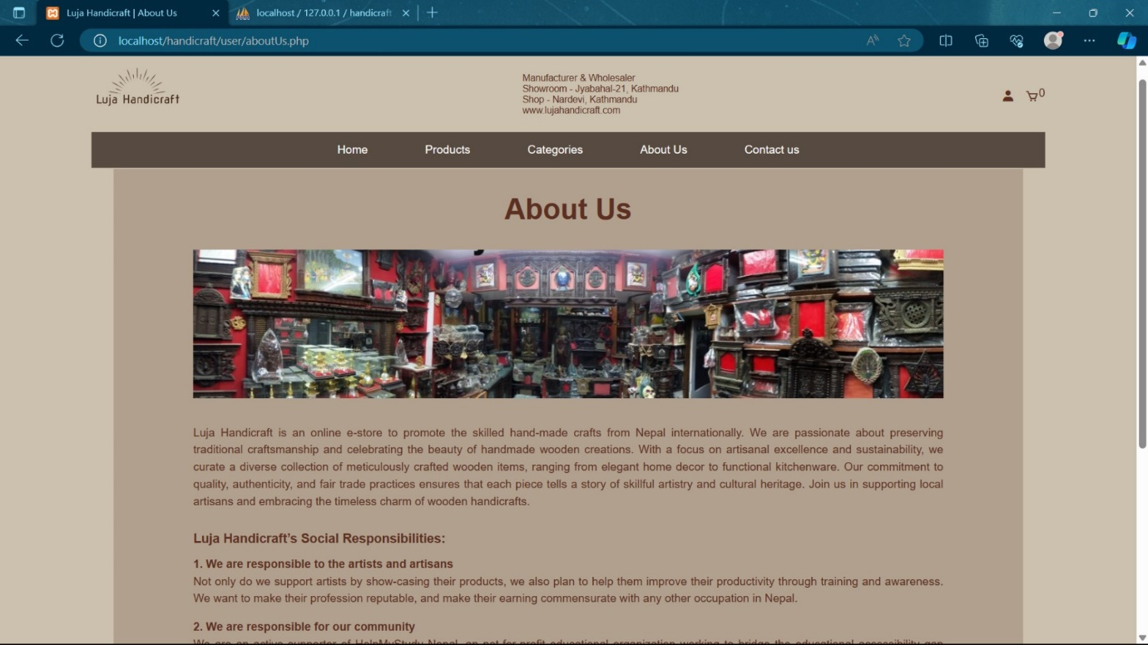

Figure 19: About us Page

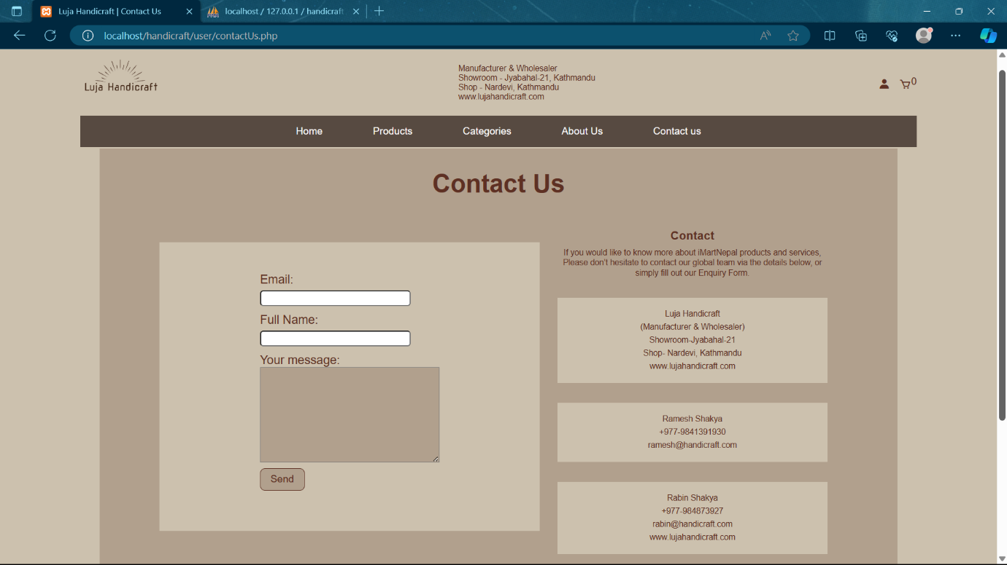

Figure 20: Contact Us Page

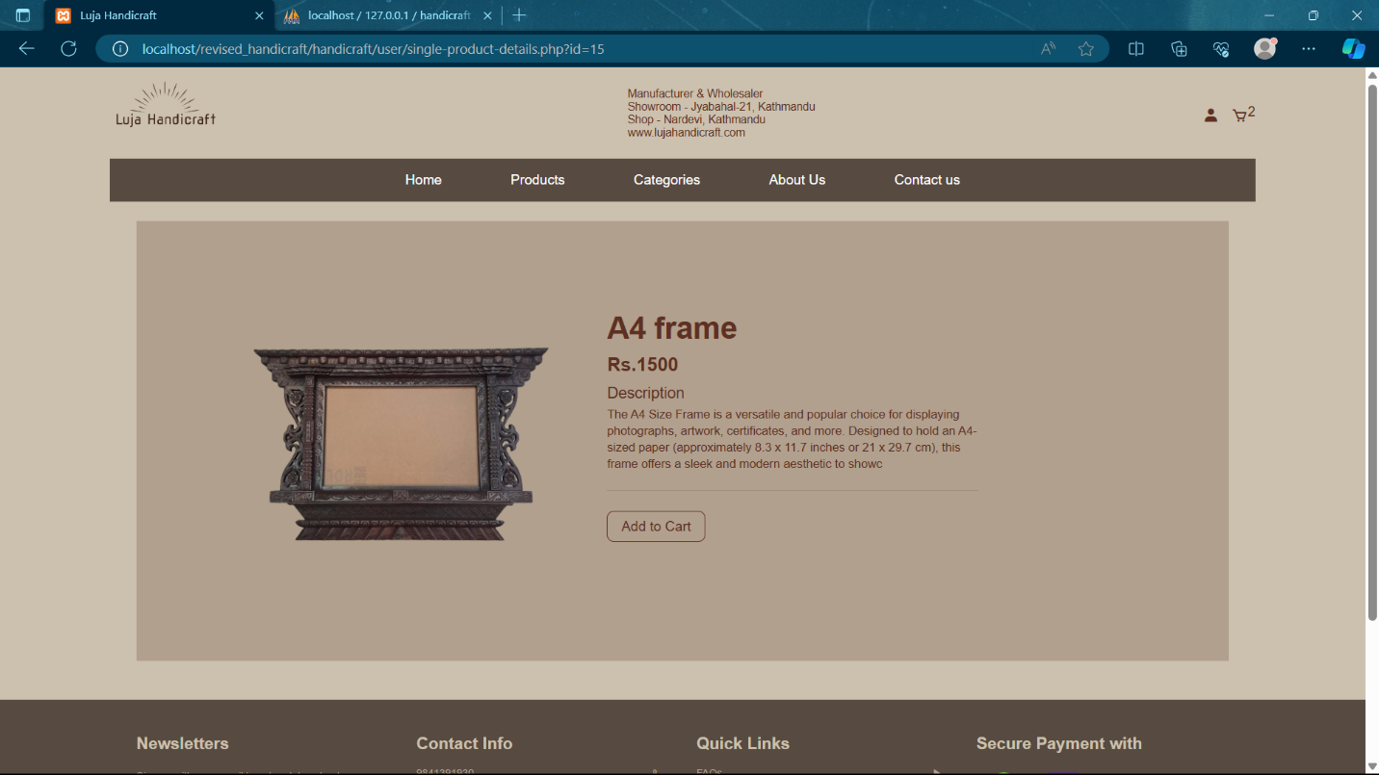

Figure 21: Single Product Page

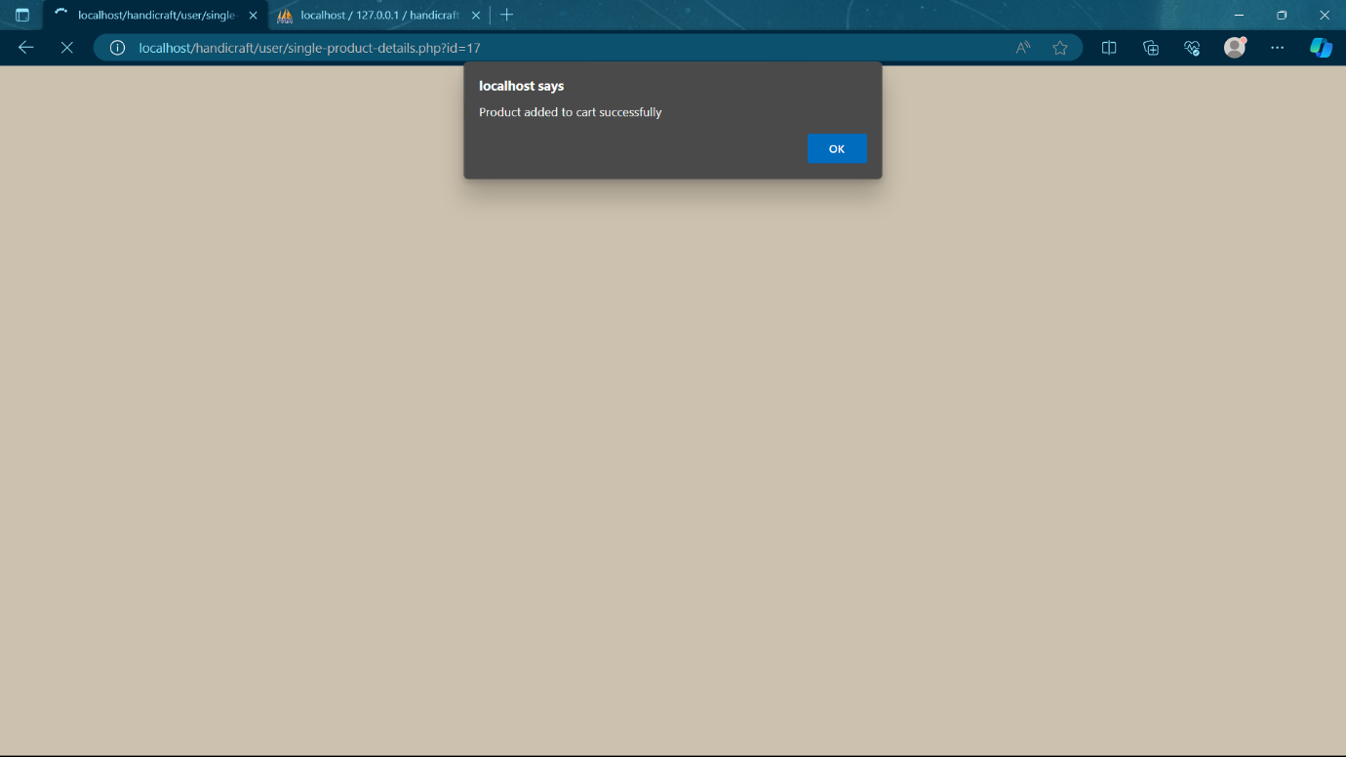

Figure 22: Product Successfully Added

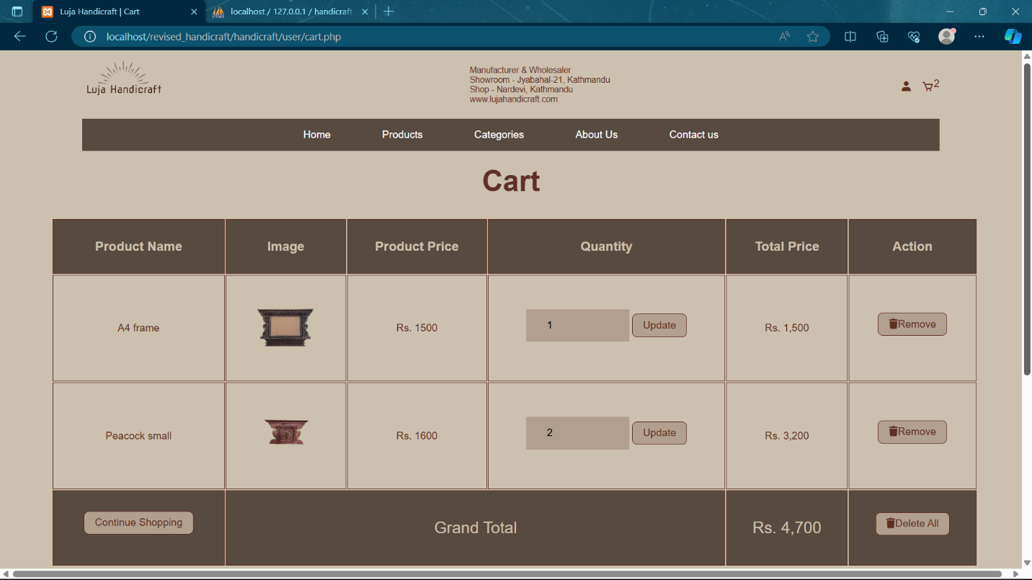

Figure 23: Cart Page

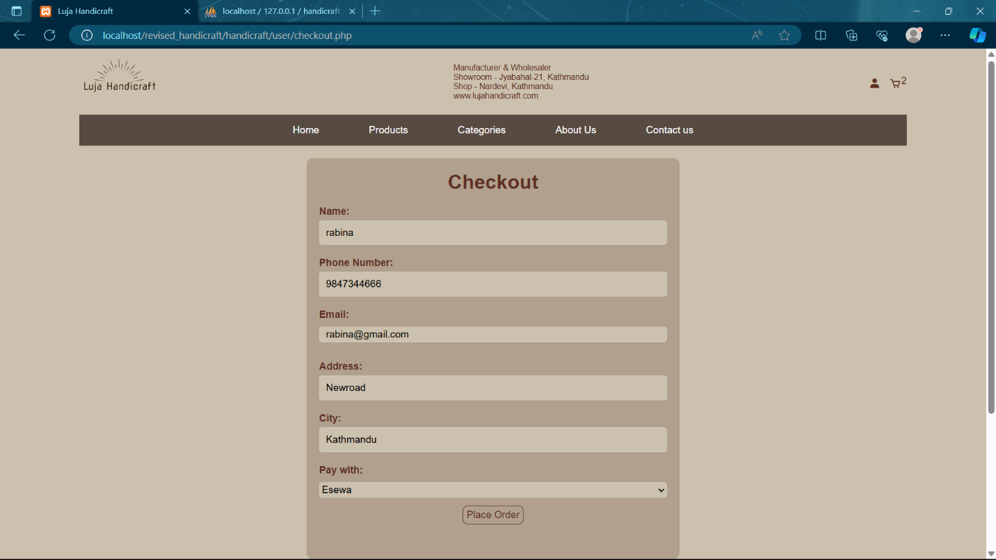

Figure 24: Checkout Page

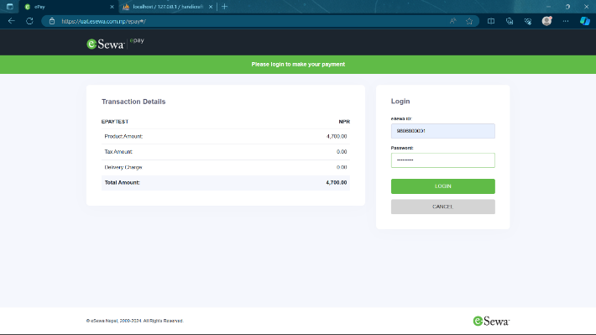

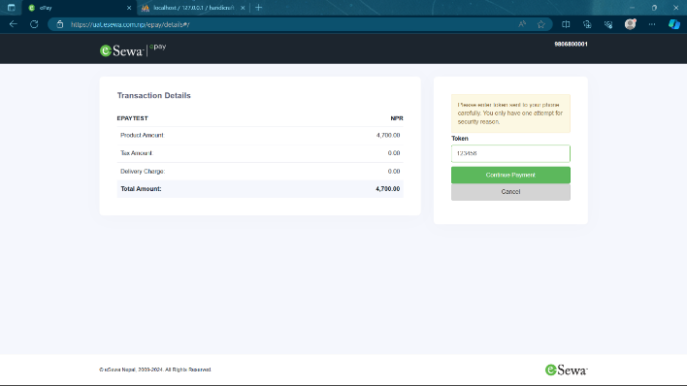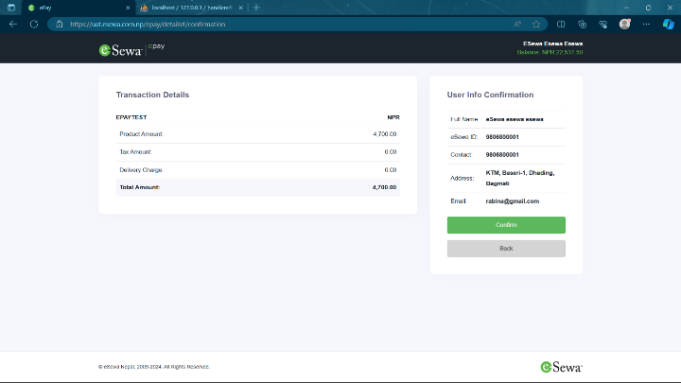

Figure 25: eSewa Integration

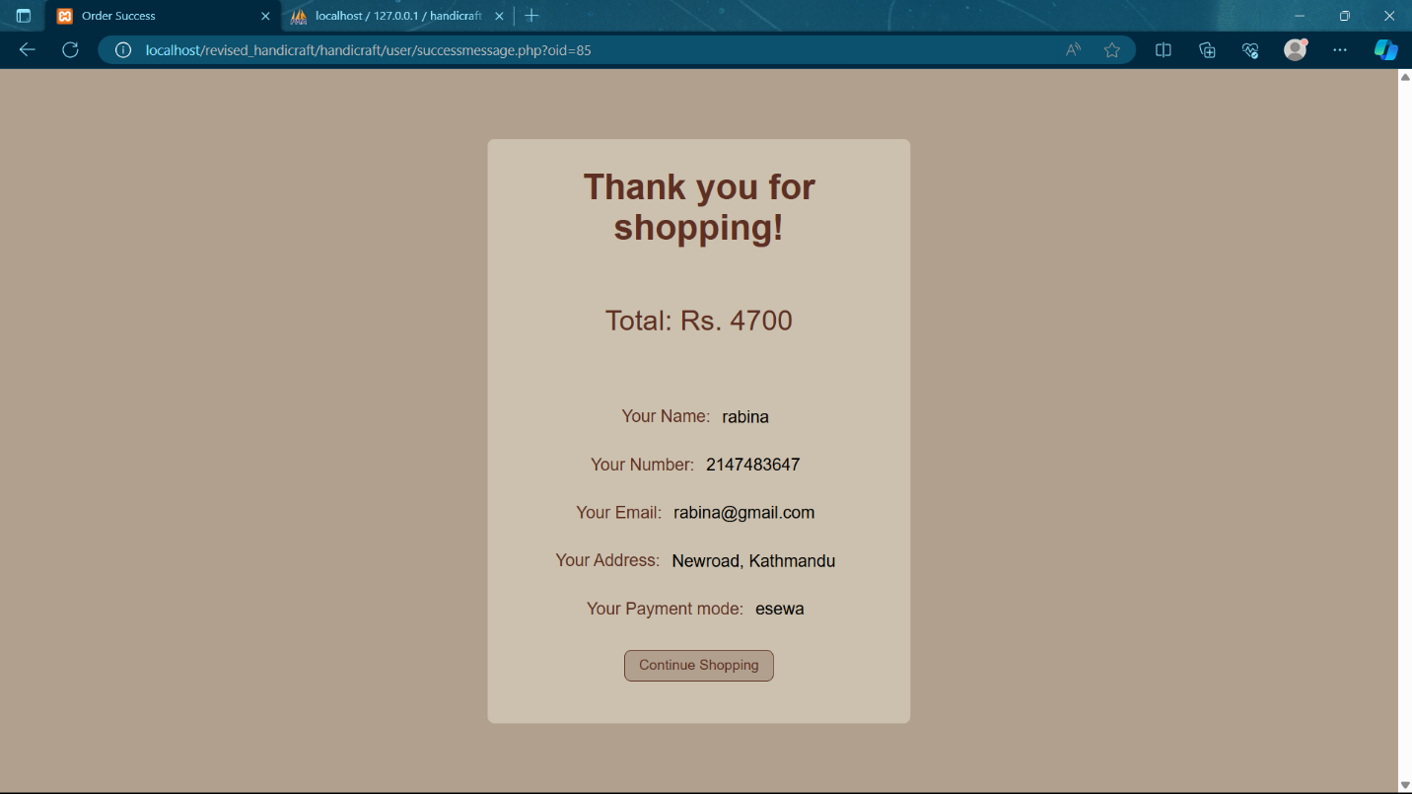

Figure 26: User Order placed successfully

**Admin Page:**

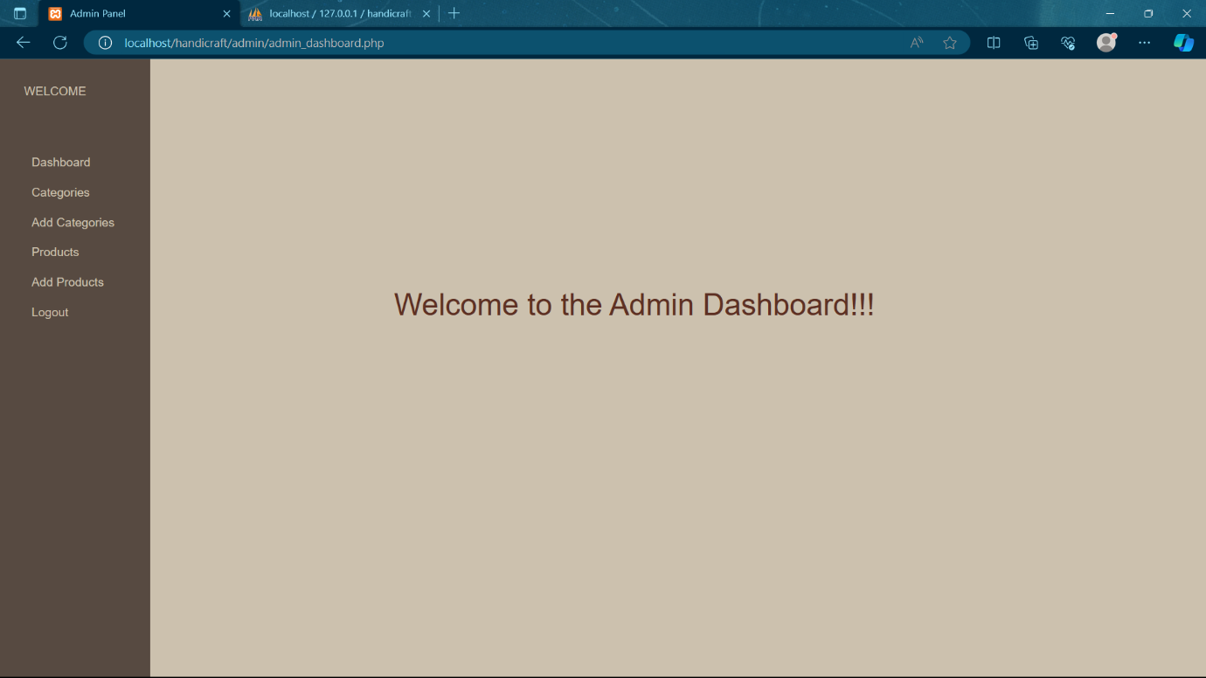

Figure 27: Admin Dashboard

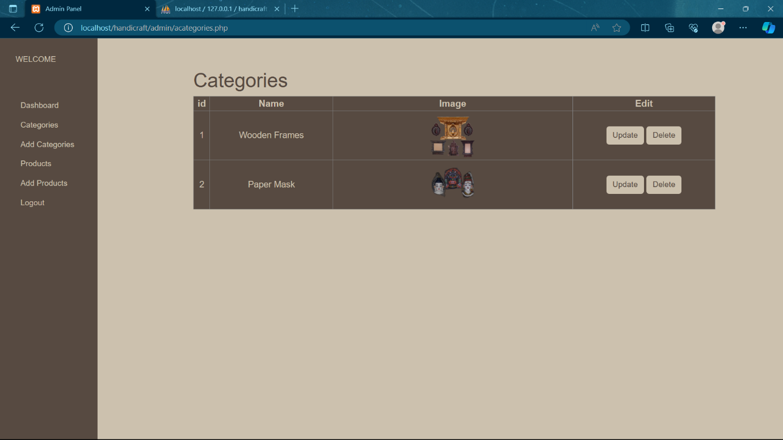

Figure 28: Categories page (before adding category)

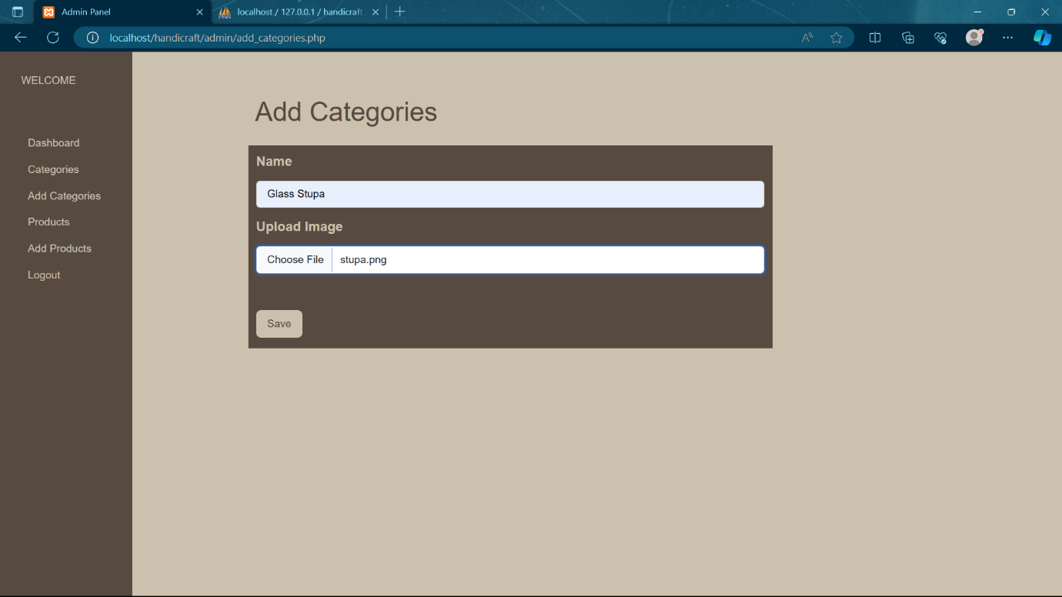

Figure 29: Add categories page

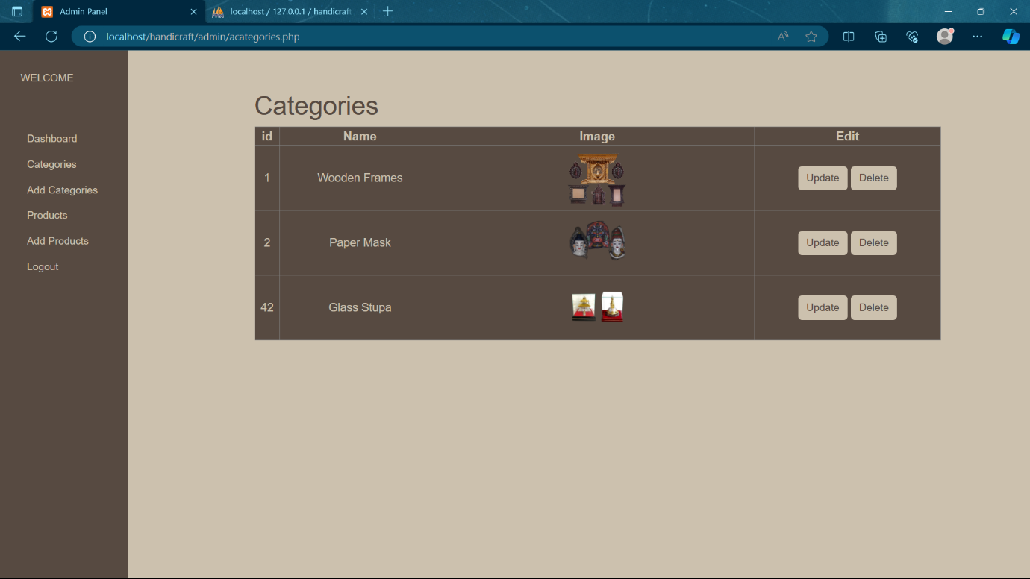

Figure 30: Categories page (after adding category)

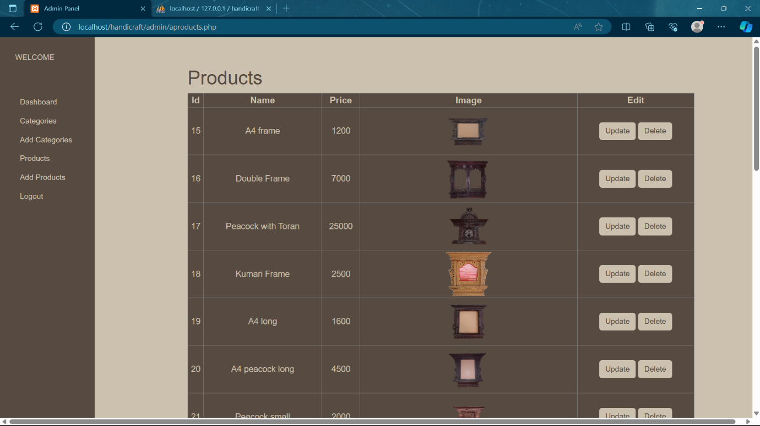

Figure 31: Products page

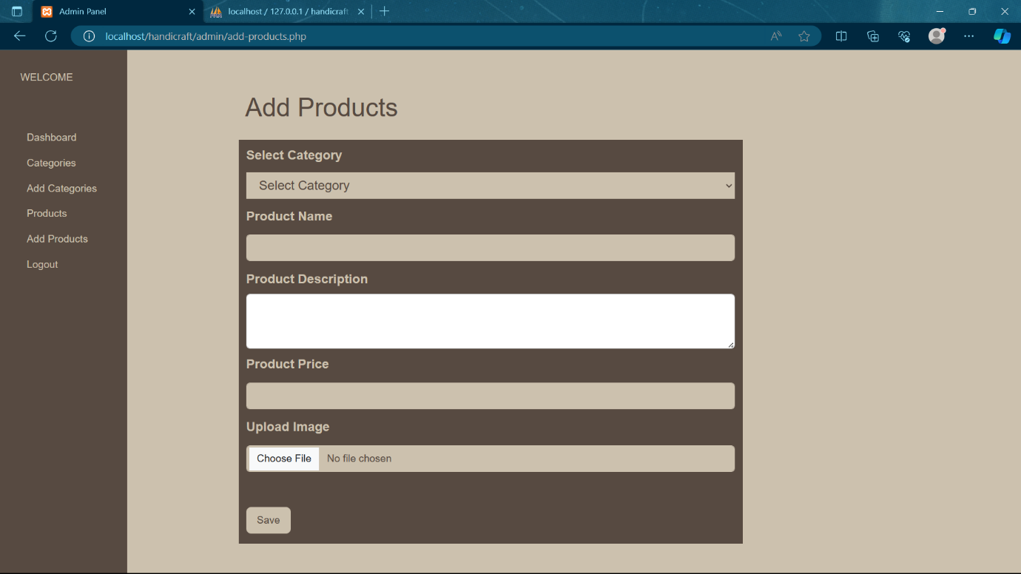

Figure 32: Add product page

**Databases (MySql):**

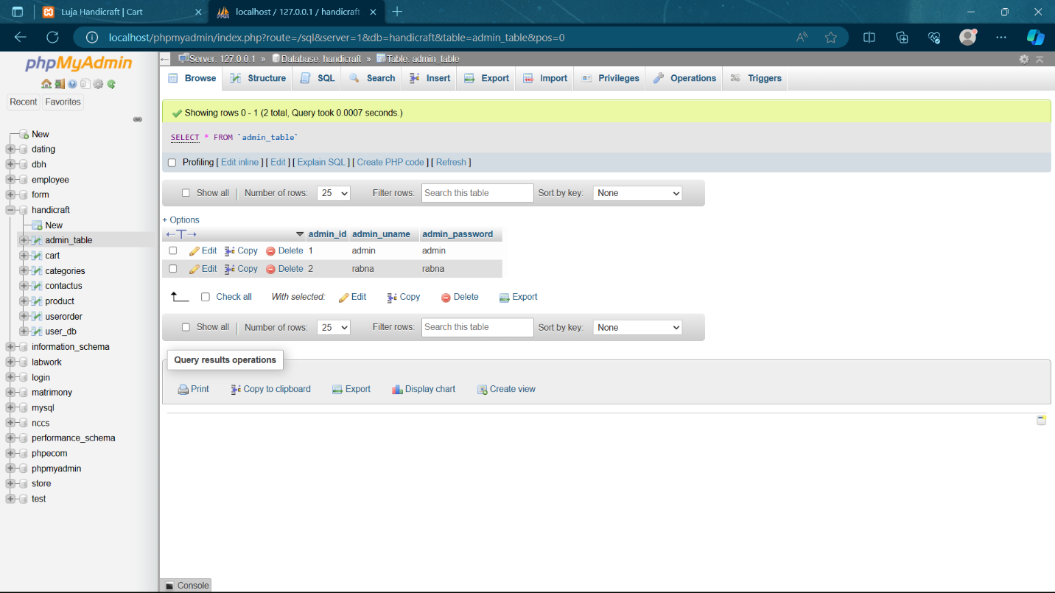

Figure 33: Admin

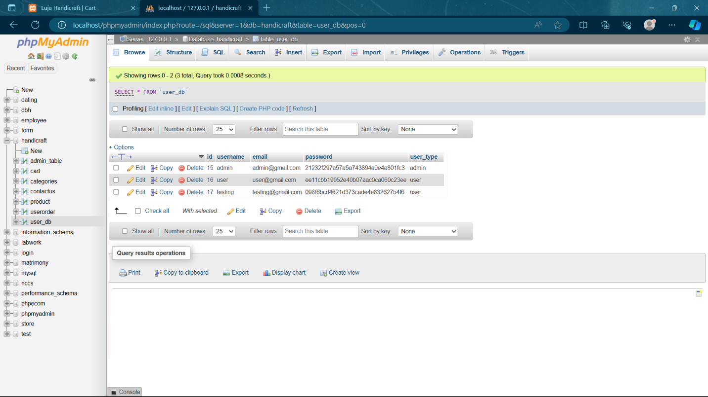

Figure 34: User

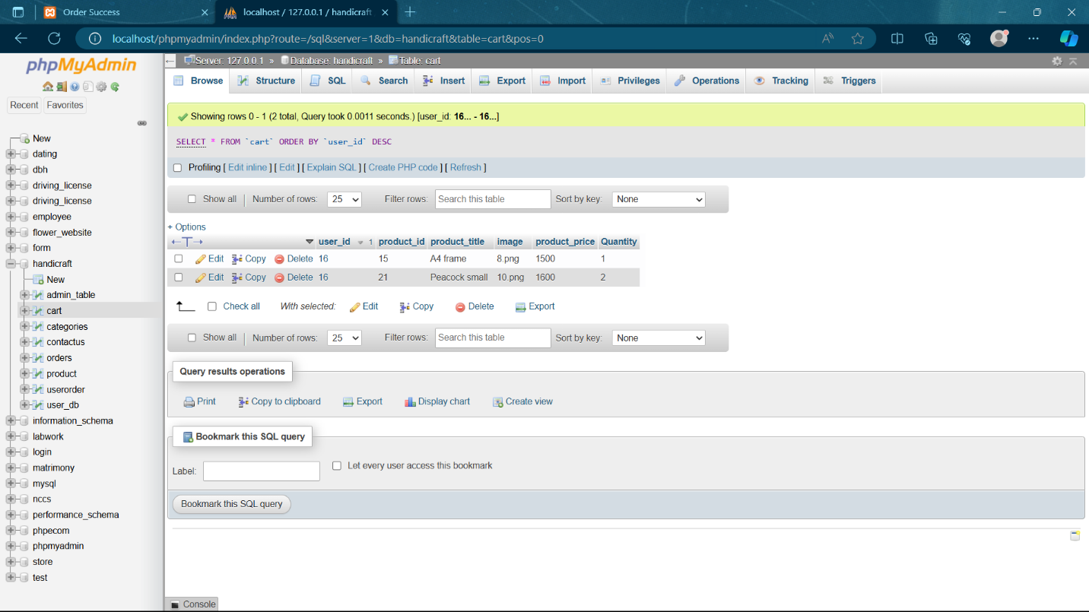

Figure 35: Cart

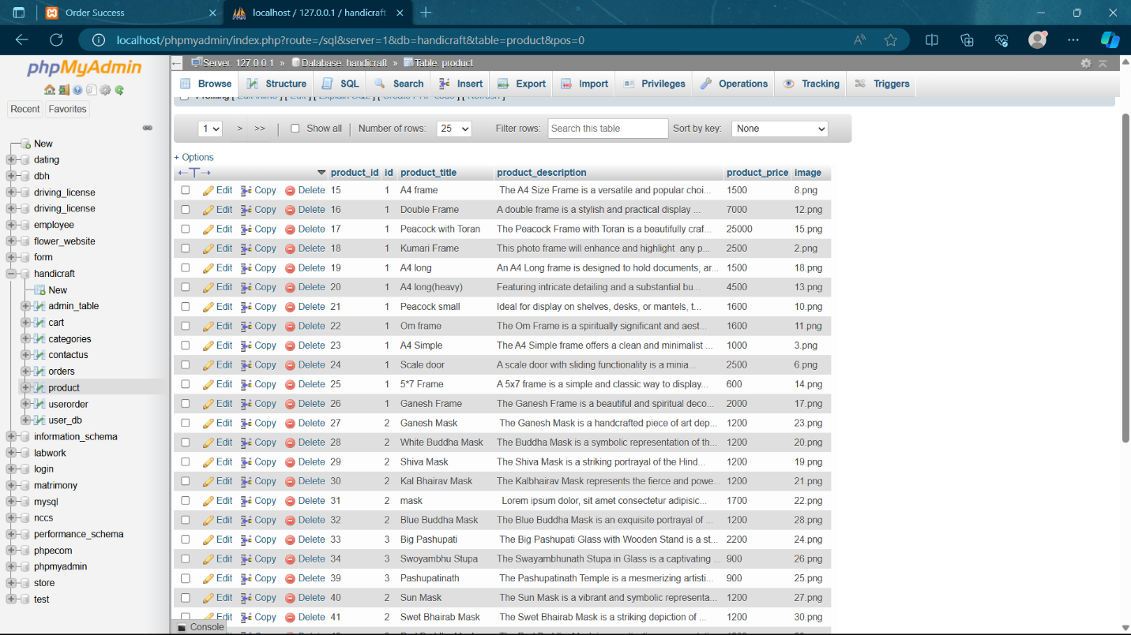

Figure 36: Product

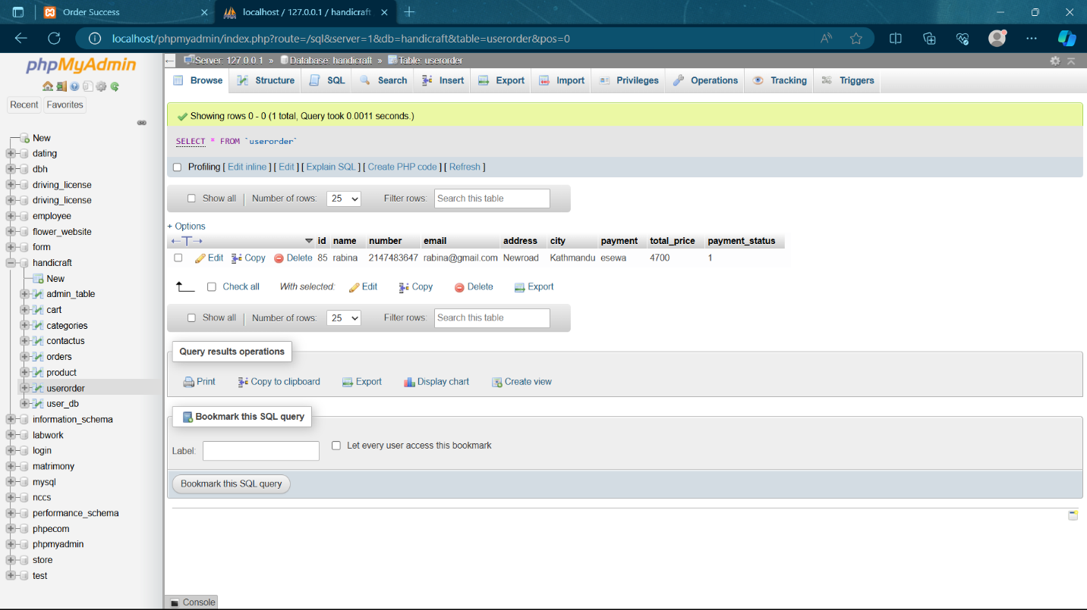

Figure 37: User Order

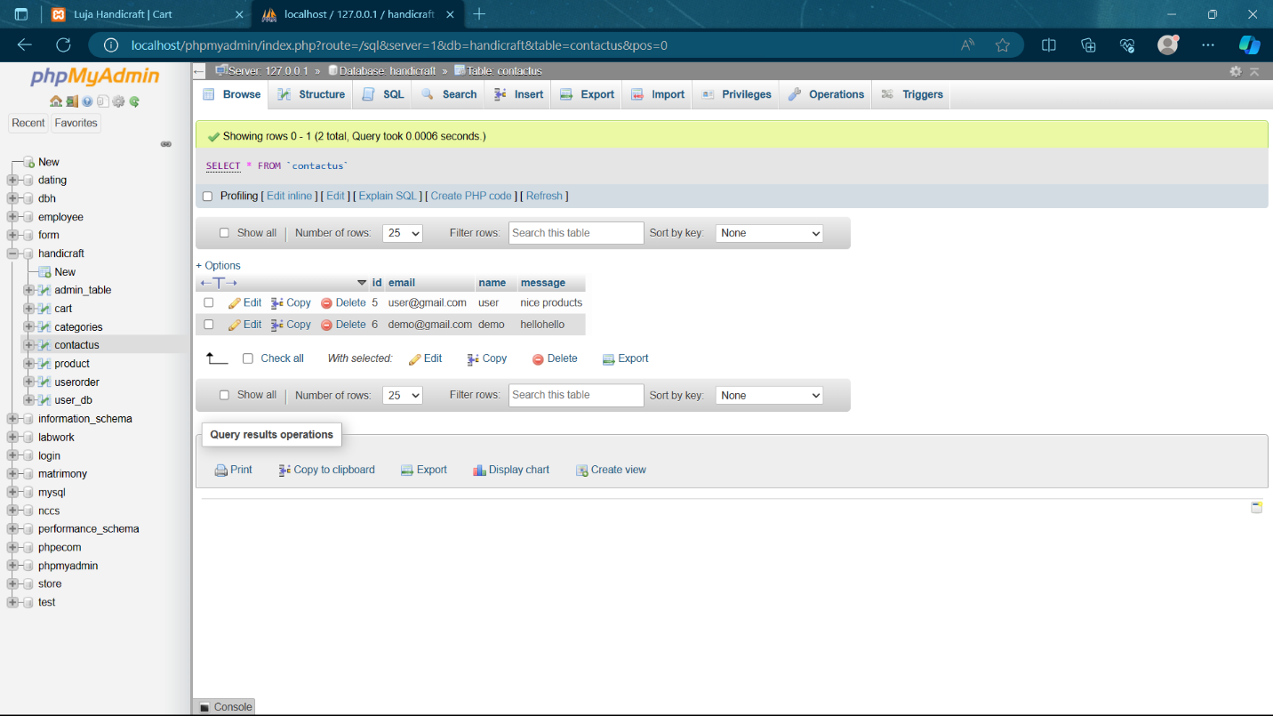

Figure 38: Contact Us